

**Software Requirements Specification**

**Project:** Creation of a web application for the ecological reserve "El Choco**"**

**Team:** #1

**Name Team:** Team Cascade

**Names:**

* López Almeida Andrés Isaías
* Malte Villarreal Dennis Marcelo
* Medina Armijos Martin Andrés
* Páez Zapata Diego Alexander

**Contents**

1 Introduction 3

1.1 Purpose 3

1.2 Scope 3

1.3 Personnel involved 3

1.4 Definitions, acronyms and abbreviations 4

1.5 References 4

1.6 Summary 4

2 general description 4

2.1 Product perspective 4

2.2 Product functionality 5

2.3 User characteristics 5

2.4 Restrictions 6

2.5 assumptions and dependency 6

3 Specific requirements 6

3.1 common interface requirements 6

3.2 functional requirements 6

3.3 non-functional requirement 6

3.3.1 Performance requirements 6

3.3.2 Security 6

3.3.3 Reliability 6

3.3.4 Availability 7

# Introduction

This document is a Software Requirements Specification (SRS) for the creation of a web application. This specification has been structured based on the guidelines given by the IEEE Recommended Practice for Specifications of Software Requirements ANSI/IEEE 830, 1998 standard.

## Purpose

The purpose of this document is to define the functional and non-functional specifications for the development of a web application that will allow reporting on the fauna that exists in the "El Choco" reserve. This will be used by students, teachers and people who want more information.

## Scope

This specification of requirements is addressed to the user of the web application, which aims to inform about the fauna that exists in the reserve "El Choco.

## Personnel involved

|  |  |
| --- | --- |
| **Name** | López Almeida Andrés Isaías |
| **Role** | Programmer, Designer, Product Owner |
| **Professional category** | Software Engineering Student |
| **Responsibility:** | Check functional and non-functional requirements, check code and documentation. |

|  |  |
| --- | --- |
| **Name** | Malte Villarreal Dennis Marcelo |
| **Role** | Programmer, Designer, Product Owner |
| **Professional category** | Software Engineering Student |
| **Responsibility:** | Check functional and non-functional requirements, check code and documentation, design UMLs. |

|  |  |
| --- | --- |
| **Name** | Medina Armijos Martin Andrés |
| **Role** | Programmer, Designer, Tester, Product Owner |
| **Professional category** | Software Engineering Student |
| **Responsibility:** | Check functional and non-functional requirements, check code and documentation, design Forms. |

|  |  |
| --- | --- |
| **Name** | Páez Zapata Diego Alexander |
| **Role** | Programmer, Designer, Product Owner |
| **Professional category** | Software Engineering Student |
| **Responsibility:** | Check functional and non-functional requirements, check code and documentation, design UMLs. |

## Definitions, acronyms and abbreviations

|  |  |
| --- | --- |
| ***Name*** | ***Description*** |
| **User** | Person who will use the web application |
| **SRS** | Software Requirements Specification |
| **FR** | Functional Requirement |
| **NFR** | Non-Functional Requirement |
| **WA** | Web Application |

## References

|  |  |
| --- | --- |
| **Document title** | **Reference** |
| Standard IEEE 830 - 1998 | IEEE |

## Summary

This document consists of three sections. The first section introduces it and provides an overview of resource specification.

In the second section of the document, a general description of the web application is made, in order to know the main functions that it must perform, the associated data and the factors, restrictions, assumptions and dependencies that affect the development, without going into excessive details.

Finally, the third section of the document is the one in which the requirements that must be met are defined in detail.

# general description

## Product perspective

The WA will be a product designed to work in WEB environments, which will allow its use quickly and efficiently.

## Product functionality

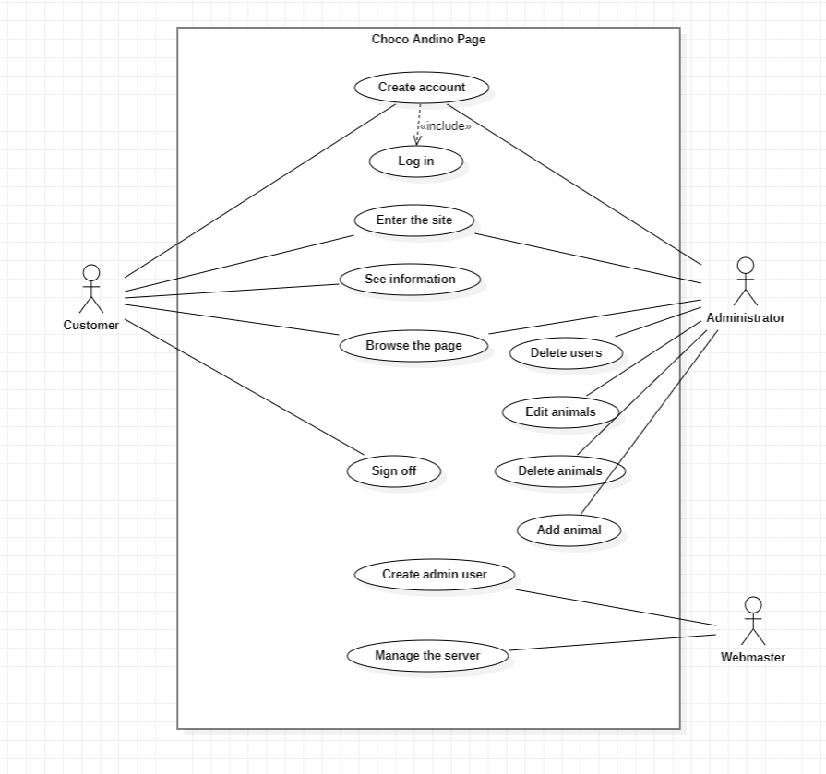

## User characteristics

|  |  |
| --- | --- |
| **Type of user** | Administrator |
| **Training** | TSU in Computer Science |
| **Activities** | Control and management of the system in general |

|  |  |
| --- | --- |
| **Type of user** | Webmaster |
| **Training** | TSU in Computer Science |
| **Activities** | Control and management of the system in general |

|  |  |
| --- | --- |
| **Type of user** | User |
| **Training** | none |
| **Activities** | Observa e indaga información |

## Restrictions

* Interface to be used with the internet.
* Domain Usage (X)
* Languages and technologies in use: HTML, JAVA.
* The servers must be able to service queries concurrently.
* The system will be designed according to a client/server model.
* The system should have a simple design and implementation, independent of the platform or the programming language.

## assumptions and dependency

* The requirements described here are assumed to be stable.
* The computers in which the system is going to be executed must meet the requirements indicated above to guarantee a correct execution of the same.

# Specific requirements

**Functional Requirements**

|  |  |
| --- | --- |
| **Identification of the requirement:** | RF01 |
| **Requirement Name:** | Register |
| **Characteristic:** | Users must register in the system to access notifications |
| **Description of the requirement** | The system will allow the user to register. The user must provide his E-mail |
| **NON-functional requirement:** | * RNF01 |
| **Request priority:**  Half | |

|  |  |
| --- | --- |
| **Identification of the requirement:** | RF02 |
| **Requirement Name:** | Consult information |
| **Characteristic:** | The system will offer the user information about the word they are looking for. |
| **Description of the requirement** | When entering a word that specifies a group of animals, the system will show information about the animals with that characteristic |
| **NON-functional requirement:** | * RNF01 * RNF02 * RNF03 |
| **Request priority:**  High | |

|  |  |
| --- | --- |
| **Identification of the requirement:** | RF03 |
| **Requirement Name:** | Show menu |
| **Characteristic:** | Users should see a menu on the right-hand side of the page |
| **Description of the requirement** | The system will show a menu (home, know us, repository, about and search) when clicking on the three horizontal lines found in the upper right |
| **NON-functional requirement:** | * RNF01 * RNF02 * RNF03 |
| **Request priority:**  High | |

|  |  |
| --- | --- |
| **Identification of the requirement:** | RF04 |
| **Requirement Name:** | Visit home |
| **Characteristic:** | The system should take you to the home page. |
| **Description of the requirement** | Directs to the home page when clicking on the home option found in the menu |
| **NON-functional requirement:** | * RNF01 * RNF02 * RNF03 |
| **Request priority:**  High | |

|  |  |
| --- | --- |
| **Identification of the requirement:** | RF05 |
| **Requirement Name:** | Visit repository page |
| **Characteristic:** | The system system leads to the repository page |
| **Description of the requirement** | Clicking on the repository option found in the menu takes you to the repository page |
| **NON-functional requirement:** | * RNF01 * RNF02 * RNF03 |
| **Request priority:**  High | |

|  |  |
| --- | --- |
| **Identification of the requirement:** | RF06 |
| **Requirement Name:** | Go to about page |
| **Characteristic:** | The system should take you to the about page of |
| **Description of the requirement** | Clicking on the about option located in the menu should take you to the about page |
| **NON-functional requirement:** | * RNF01 * RNF02 * RNF03 |
| **Request priority:**  High | |

|  |  |
| --- | --- |
| **Identification of the requirement:** | RF07 |
| **Requirement Name:** | See animals |
| **Characteristic:** | The system will display a list of animals with different characteristics of the same |
| **Description of the requirement** | Clicking on repository will display a list of animals |
| **NON-functional requirement:** | * RNF01 * RNF02 * RNF03 |
| **Request priority:**  High | |

|  |  |
| --- | --- |
| **Identification of the requirement:** | RF08 |
| **Requirement Name:** | Add animals |
| **Characteristic:** | The system will allow adding animals with different characteristics of the same |
| **Description of the requirement** | By clicking on the edit button you will be able to modify information about it |
| **NON-functional requirement:** | * RNF01 * RNF02 * RNF03 |
| **Request priority:**  High | |

|  |  |
| --- | --- |
| **Identification of the requirement:** | RF09 |
| **Requirement Name:** | Delete animals |
| **Characteristic:** | The system will allow you to remove animals from the list, these will be removed from the database |
| **Description of the requirement** | When clicking on the delete button found in the list of animals, an option will appear where it is necessary to confirm the elimination of the chosen animal |
| **NON-functional requirement:** | * RNF01 * RNF02 * RNF03 |
| **Request priority:**  High | |

|  |  |
| --- | --- |
| **Identification of the requirement:** | RF10 |
| **Requirement Name:** | Edit animals |
| **Characteristic:** | The system will allow you to edit the information of the chosen animal and these changes will be saved in the database |
| **Description of the requirement** | By clicking on the edit button, a screen will appear where the characteristics of the animal will appear, which can be edited |
| **NON-functional requirement:** | * RNF01 * RNF02 * RNF03 |
| **Request priority:**  High | |

**Non-Functional Requirements.**

|  |  |
| --- | --- |
| **Identification of the requirement:** | RNF01 |
| **Requirement Name:** | System interface. |
| **Characteristic:** | The system will present a simple user interface to make it easy for users of the system. |
| **Description of the requirement** | The system must have an intuitive and simple user interface. |
| **Request priority:**  High | |

|  |  |
| --- | --- |
| **Identification of the requirement:** | RNF02 |
| **Requirement Name:** | Help in the use of the system |
| **Characteristic:** | The user interface must present a help system so that the users of the system facilitate their work in terms of managing the system. |
| **Description of the requirement** | The interface must be complemented with a good system for easy understanding |
| **Request priority:**  High | |

|  |  |
| --- | --- |
| **Identification of the requirement:** | RNF03 |
| **Requirement Name:** | Maintenance |
| **Characteristic:** | The system must have an installation manual and a user manual to facilitate the maintenance that will be carried out by the administrator. |
| **Description of the requirement** | The system must have easily updated documentation that allows maintenance operations to be carried out with the least possible effort. |
| **Request priority:**  High | |

|  |  |
| --- | --- |
| **Identification of the requirement:** | RNF04 |
| **Requirement Name:** | Performance |
| **Characteristic:** | The system will guarantee users a performance regarding the data stored in the system, offering reliability to it. |
| **Description of the requirement** | Guarantee system performance. In this sense, the information stored or records made may be consulted and updated permanently and simultaneously, without affecting the response time. |
| **Request priority:**  High | |

|  |  |
| --- | --- |
| **Identification of the requirement:** | RNF05 |
| **Requirement Name:** | Information security |
| **Characteristic:** | The system will guarantee users security regarding the information that is processed in the system. |
| **Description of the requirement** | Guarantee the security of the system with respect to the information and data that are handled, such as documents, files and passwords. |
| **Request priority:**  High | |

## Common Interface Requirements

### user interfaces

The user interface will consist of a set of windows with buttons, lists and text fields. This must be built specifically for the proposed system and will be viewed from an internet browser.

### Hardware interfaces

It will be necessary to have computer equipment in perfect condition with the following characteristics:

* Network adapters.
* 1.66GHz or higher processor.
* Minimum memory of 256Mb.
* Mouse.
* Keyboard.

### software interfaces

Operating System: Windows XP or higher.

Browser: Mozilla or Chrome.

### communication interfaces

Servers, clients and applications will communicate with each other, using standard Internet protocols, whenever possible. For example, to transfer files or documents, existing protocols (FTP or other suitable) should be used.

## functional requirements

### Functional requirement 1

**Enter email:** users must enter their email

## non-functional requirement

### Performance requirements

* Ensuring that query design or other processing does not impact database performance or significantly affect network traffic.

### Security

* Guarantee the reliability, security and performance of the computer system to the different users. In this sense, the information stored or records made may be consulted and updated permanently and simultaneously, without affecting the response time.
* Guarantee the security of the system with respect to the information and data that are handled, such as documents, files and passwords.
* Facilities and controls to allow access to information to authorized personnel through the Internet, with the intention of consulting and uploading relevant information for each of them.

### Reliability

* The system must have an intuitive and simple user interface
* The user interface must adjust to the characteristics of the institution's website, within which the process management system and inventory will be incorporated.

### Availability

The availability of the system must be continuous with a level of service for users of 7 days for 24 hours, guaranteeing an adequate scheme that allows the possible failure of any of its components, having a contingency, generating alarms.

### Maintainability

* The system must have easily updated documentation that allows maintenance operations to be carried out with the least possible effort.
* The interface must be complemented by a good help system (administration may fall to personnel with little experience in the use of computer applications).

### Portability

* The system will be implemented under the Windows platform.